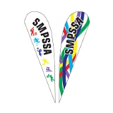

SMPSSA CODE OF BEHAVIOUR
We encourage sportsmanship and a safe environment at SMPSSA events and carnivals; and expect competitors, officials and spectators to embrace our – ‘Code of Behaviour’.
- Respect the rights, dignity and worth of every person regardless of their gender, ability, cultural background or religion.
- Students are involved in events and carnivals for their enjoyment.
- Encourage students to play by the rules.
- Focus on your student’s/child’s efforts and performance, rather than winning or losing.
- Remember, students learn best by example. Appreciate good performances and skilful play by all participants.
- Verbal and physical abuse has no place in sport, and we need to support all efforts to stamp it out.
- Respect official’s decisions.
- Show appreciation for volunteers, coaches, officials and administrators.

